|  |  |  |
| --- | --- | --- |
| **ر**  **ردیف دفتر ثبت** |  | **زهره مثنا**  **Official English Translator to the Judiciary**  **License No. 1387**  **Zohre Mosana**  **To verify the authenticity of the translation, please scan the QR Code** |

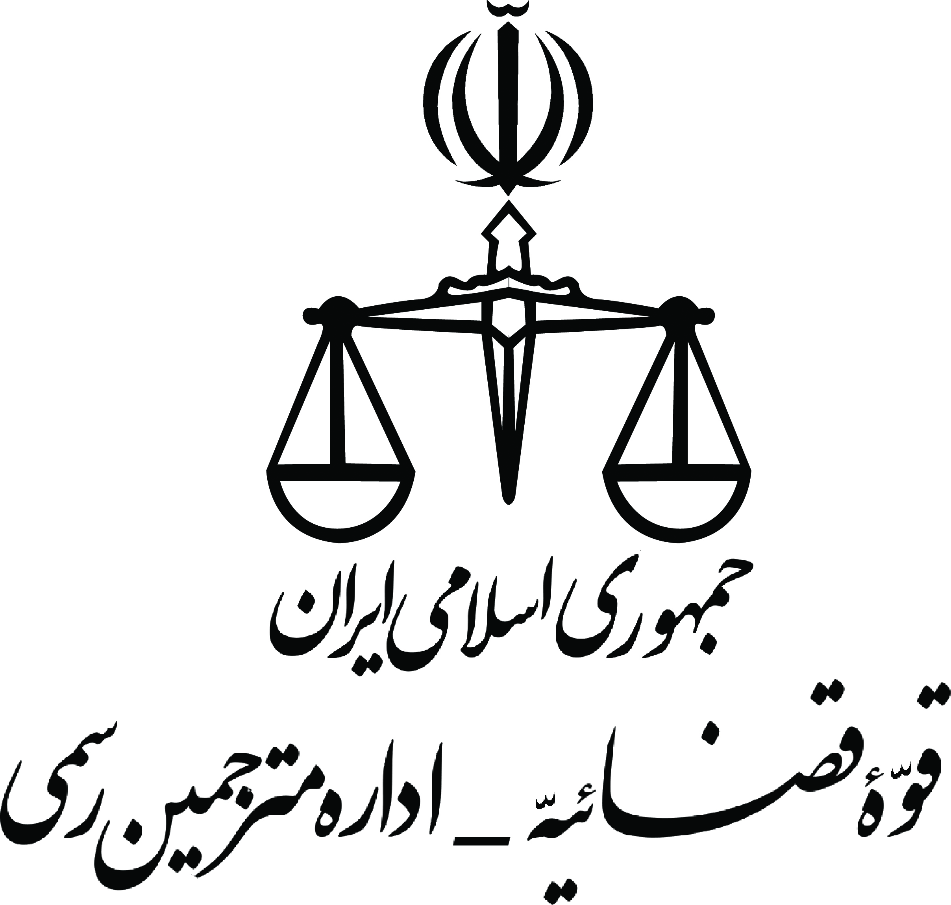

*Official translation from Persian*

Emblem

**National Iranian Oil Company**

**Iranian Offshore Oil Company**

Ref. No.: 00097

Date: 09.05.2023

Subject: **Grant of Temporary Leave**,

*This is hereby to certify that:*

**Mr. Peyman Rashidi,** sun of Javad, born on 23.08.1971, holder of the national ID number: 3961783357 and birth Certificate number: 282, issued in Nahavand, official employee of the Iranian Offshore Oil Company of Iran is granted a temporary leave from work to accompany his daughter and wife during the latter’s studies in Canada and to return back to Iran to take up his responsibilities once his family is settled.

This certificate is issued upon the request of the above-mentioned name concerning the *Ministry of Immigration, Refugees, and Citizenship Canada (IRCC)* and has no other value.

*National Iranian Oil Company*

*National Offshore Iranian Oil Company*

*Head of Personnel Affairs - Dariush Feli Malayeri [Signed and Sealed]*

True translation from Persian is certified. Tehran – May 29, 2023

**نام صاحب سند: پیمان رشیدی – هزینه ترجمه و خدمات دفتری: 955000 ریال بابت ترجمه سایر گواهی ها**

**آدرس: سعادت آباد، بین سپیدار و سرو ، پلاک 67، طبقه سوم، واحد 2**

Address: Apt No. 2, 3rd floor, No.67, Between Sarv and Sepidar st, Saadat Abad, Tehran, Iran

email: [z.mosanna@yahoo.com](mailto:z.mosanna@yahoo.com) Mobile : (+98)9125462247 Tel : (+98)2122465527